# **Join Domain Windows**

**Steps To Join Windows To Active Directory:**

1. Go to Network & Internet Settings.

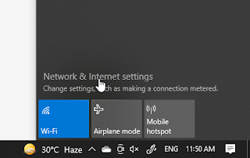

1. Click Network and Sharing Center.

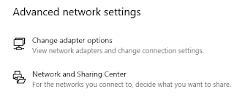

1. Click Connections.

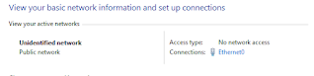

1. Click Properties.

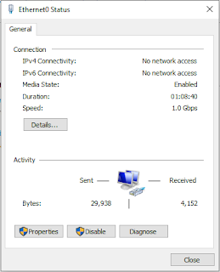

1. Select Internet Protocol Version 4. Click Properties.

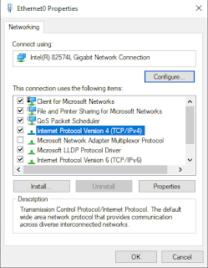

1. Choose Use the following DNS server addresses. Enter Active Directory IP into Preferred DNS server. Click OK and close all appeared windows.

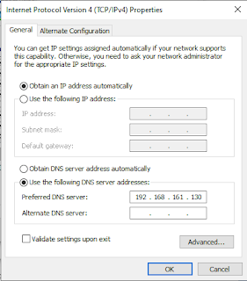

1. Open CMD.
2. Test connection to Active Directory by using command ping. ping ANGELO.NET as an example. If have replied, it's mean that you can connect to your Active Directory.

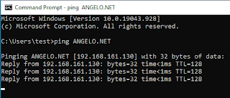

1. Go to Settings > System > About.

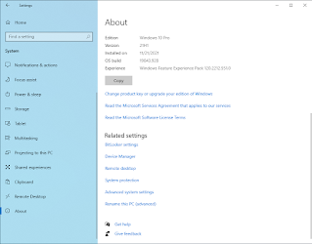

1. Click Advanced system settings.

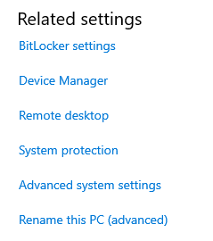

1. At the Computer Name tab, click Change.

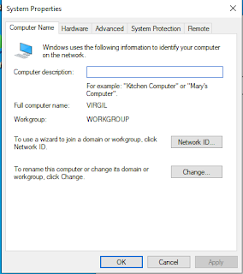

1. Choose Domain, enter the domain name of the Active Directory that you want to join. Click OK.

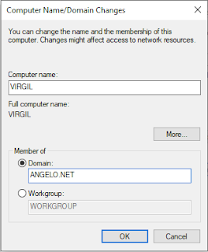

1. Enter Active Directory credentials. Click OK.

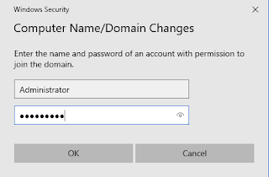

1. Join Active Directory success if this window pop up.

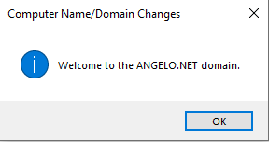

1. Close everything and restart your computer.

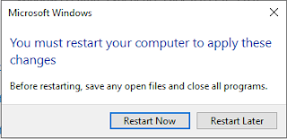

1. After restart, go to Settings > System > About. Click Advanced system settings. If the Full device name has the name of your computer and domain, it's mean that you have successfully joined a Windows computer to Active Directory.

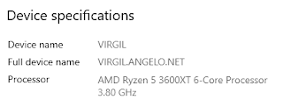

**Steps How To Remove Domain:**

1. Go to Settings > System > About. Click Advanced system settings. At the Computer Name tab, click Change.

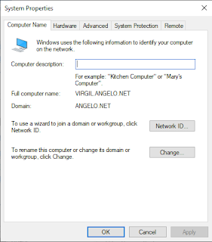

1. Choose Workgroup, enter WORKGROUP inside it. Click OK.

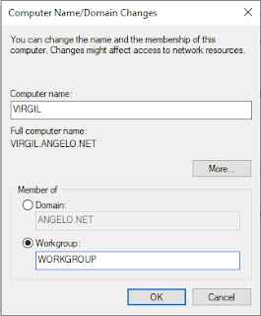

1. Please make sure you remember the administrator password for your computer. Click OK.

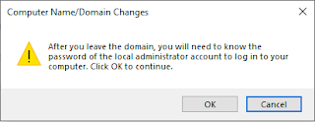

1. Enter the username and password of an account that has permission to manage Active Directory. Click OK.

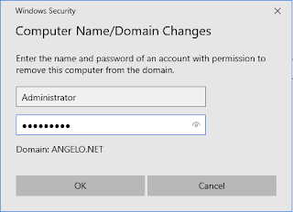

1. Remove Active Directory success if this window pop up.

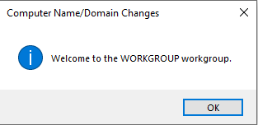

1. Close everything and restart your computer.

